

**BSCs in Computing**

**SWE5205: Modern Applications**

**2023/2024(Semester 2)**

**By – Maheen Shabir Ahmed**

**Student No: 2230656**

**Help Desk System for University of Bolton**

**Tutor name - Mr. Abdurrahman**

**Assignment2**

# **TABLE OF CONTENTS**

**TABLE OF CONTENTS** 2

**TASK 4** 3

**Software development models** 3

3a) Critically analyze software models. 3

3b) Evaluate agile methodologies 6

3c) Suitable models for Help Desk System. 8

**TASK 4** 8

**Fully Functional Modern Help Desk System** 8

4a) Be connected to a backend database 8

4b) Have a secured login and registration page 9

4c) Run on cross-platform (both mobile and web) 11

4d) Integrate e-marketing techniques. 15

4d) Integrate multiple features that includes but not limited to: 19

Complaint management 19

Event management 21

Profile management 22

Appointment management 23

4e) Provide feature enhancement of the project. 25

**TASK 5** 27

**Application Testing Methods** 27

5a) Examine testing methodologies 27

5b) Produce a test plan and test cases as evidence for testing the application. 28

**Test plan** 28

**Test cases** 28

**REFERNCING** 37

**Website** 37

**Book** 37

**Journal** 37

**Images** 37

# **TASK 4**

## **Software development models**

### 3a) Critically analyze software models.

Software models are like blueprints for programs, showing how they should function and interact, helping developers plan and create software efficiently.

**Waterfall Model**

The waterfall model is like building a house where each phase, like planning, construction, and finishing, follows a sequential order without going back. Its advantages are clear milestones and documentation, but drawbacks include difficulty handling changes and long development cycles. **(Cortellessa, Antinisca Di Marco and Inverardi, 2011)**

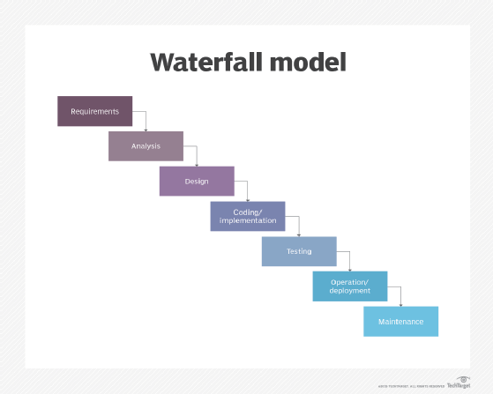

Fg1: (Ttgtmedia.com, 2024)

|  |  |
| --- | --- |
| Advantages | Disadvantages |
| Structured progress: Clear, step-by-step advancement. | Limited flexibility hard to adapt quickly. |
| Predictable Milestones easily tack progress points. | Late Issue Discovery problems uncovered late. |
| Clear Documentation detailed , organized project records. | Lengthy development cycles time-consuming , especially late is this in human. |

**Agile Model**

The Agile model is akin to a dynamic blueprint of software development, focusing on iterative cycles called sprints, frequent collaboration among team members and stakeholders, and the ability to swiftly responds to evolving requirements and feedback, promoting faster and more customer-centric delivery of software solutions. **(Cortellessa, Antinisca Di Marco and Inverardi, 2011)**

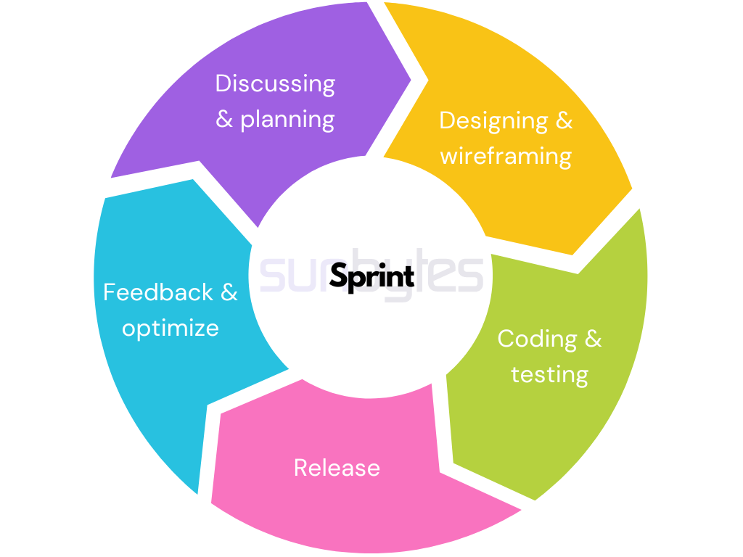

Fg2: (Sunbytes.io, 2024)

|  |  |
| --- | --- |
| Advantages | Disadvantages |
| Rapid, useful delivery. | Uncertain effort estimation |
| Emphasis on interactions | Less design, documentation |
| Frequent software delivery | Less initial planning |

**Spiral Model**

The Spiral model is like climbing a mountain with iterative loops, where each loop represents a phase of the project such as planning, risk analysis, development, and evaluation. It emphasizes risk management by addressing potential issues early and allows for flexibility and continuous improvement through feedback loops, ensuring a structured yet adaptable approach to software development. **(Cortellessa, Antinisca Di Marco and Inverardi, 2011)**



Fg3: (Wikimedia.org, 2024)

|  |  |
| --- | --- |
| Advantages | Disadvantages |
| Early software production | Costly for small projects. |
| Effective risk handling | Complex process |
| Flexible requirement | Dependency on risk analysis. |

**V-Model**

The V-Model is like building a staircase: as you ascend the development phases, you simultaneously descend through testing phases. This approach ensures that testing is integrated early and thoroughly, catching issues before they escalate and leading to more robust and reliable software outcomes. **(Cortellessa, Antinisca Di Marco and Inverardi, 2011)**

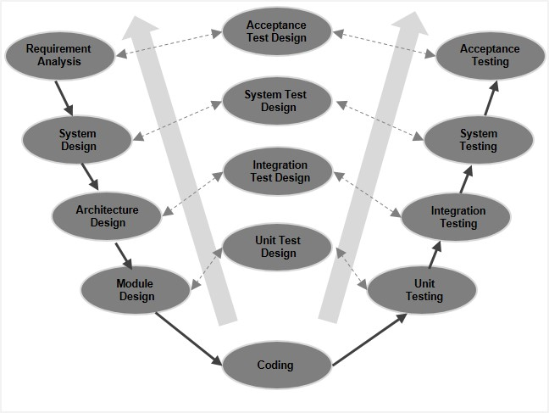

Fg4: (Tutorialspoint.com, 2024)

|  |  |
| --- | --- |
| Advantages | Disadvantages |
| Easy and straightforward | Rigid and inflexible |
| Early testing saves time | No early prototypes |
| Proactive defect detection. | Changes require document updates. |

### 3b) Evaluate agile methodologies

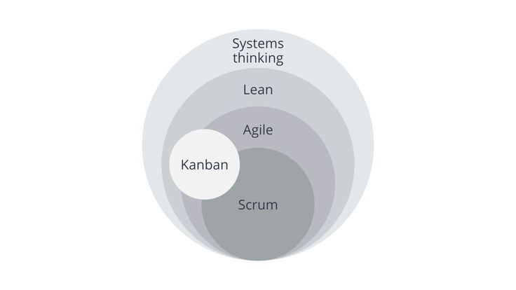

Fg5: (Pinimg.com, 2024)

Evaluating agile methodologies means reviewing their performance, gauging their flexibility, and examining their influence on project success. It’s entails assessing feedback, measuring team productivity, and pinpointing opportunities for enhancement.

**SCRUM**

Scrum is like a team huddle in sports, where everyone collaborates closely to score the winning goal of a successful project. Its short sprints are like quick plays, allowing for rapid adjustments based on the opponent’s moves, or in this case, changing project needs. The daily stand-up meetings are akin to halftime talks, keeping everyone aligned and focused on the game plan. Regular reviews act likes post-game analyses, learning from each match to improve strategies for the future wins. **(Koch, 2004)**

|  |  |
| --- | --- |
| Advantages | Disadvantages |
| Rapid iteration cycles | Require experienced scrum master |
| Flexibility to change | Potential for scope creep |
| Promotes collaboration and teamwork | Can be time-consuming |

**AGILE**

Agile is a broader approach that values customer collaboration, adaptive planning, and continuous improvement. It focuses on delivering working software frequently, responding to feedback, and fostering a flexible, customer-centric mindset. **(Koch, 2004)**

|  |  |
| --- | --- |
| Advantages | Disadvantages |
| Customer collaboration boosts satisfaction. | Requires experienced team. |
| Flexibility adapts to changes. | Risk of scope creep. |
| Iterative approach enhances quality. | Continuous feedback needs management. |

**LEAN**

Lean methodology is all about streamlining operations to reduce waste and maximize the delivery of value to customers. It prioritizes efficiency by identifying and eliminating non-value-added activities that don’t contribute to the end product or customer satisfaction. This involves optimizing processes for speed and quality, ensuring that resources are used effectively and that outputs meet high standards. By focusing on lean principles, organizations can achieve greater productivity, improved customer satisfaction, and sustainable long-term success. **(Koch, 2004)**

|  |  |
| --- | --- |
| Advantages | Disadvantages |
| Minimize wate, maximize value | Requires cultural shift. |
| Efficient processes, improved quality. | Initial implementation challenges. |
| Focus on continuous improvement. | Overemphasis on cost-cutting. |

**Extreme programming (XP)**

Extreme Programming (XP) is an agile framework know for robust engineering practices like pair programming and test-driven development (TDD). It emphasizes collaboration and communication within teams, ensuring high-quality code and responsiveness to change. Continuous integration is key aspect, integrating code changes frequently to detect issues early. XP also promotes frequent releases, delivering unable software increments for feedback and iterative improvement. These practices create a culture of adaptability, quality, and customer satisfaction, making XP a valuable approach for dynamic software development projects. **(Koch, 2004)**

|  |  |
| --- | --- |
| Advantages | Disadvantages |
| Collaborative, iterative development. | Requires skilled team. |
| Emphasis on high quality. | Time-consuming processes |
| Responsiveness to changing requirements. | Potential for over-engineering. |

**Kanban**

Kanban is visual management tool that helps teams visualize work, limit work in progress (WIP), and optimize workflow. It promotes transparency, flexibility, and continuous delivery by focusing on incremental improvements and balancing workloads. **(Koch, 2004)**

|  |  |
| --- | --- |
| Advantages | Disadvantages |
| Visual workflow management. | Lack of strict structure. |
| Flexible and adaptable. | Requires disciplined implementation. |
| Continuous delivery focus. | Limited for complex projects. |

### 3c) Suitable models for Help Desk System.

The university of Bolton Help Desk System is web-based application accessible through any browser. Its development cycle includes:

* Clearly defined MVP requirements.
* Weekly feedback and revisions.
* Deadlines and expectations.
* Feature enhancement
* Involvement of novice programmers.
* Mapping to organizational goals.
* Continuous feature improvement.

This approach supports constant feedback, iterative improvements, and evolving features, making Agile methodology an ideal choice. Breaking down requirements into features facilitates early and frequent delivery, prioritizing essential needs and refining based on feedback. Weekly feedback aligns with Agile’s transparency and review processes, aiding in skill development and feature enhancement. Embracing Agile ensures effective project management, meeting deadlines, and fulfilling expectations for the Help Desk System.

# **TASK 4**

## **Fully Functional Modern Help Desk System**

### 4a) Be connected to a backend database

Every university relies on a robust backed database system to maintain comprehensive records of students, faculty, and internal processes, ensuring accountability and providing a reliable reference point. At the University of Bolton, we utilize phpMyAdmin through the XAMPP Control Panel to effectively Manages and organize the university’s data interfastructure.

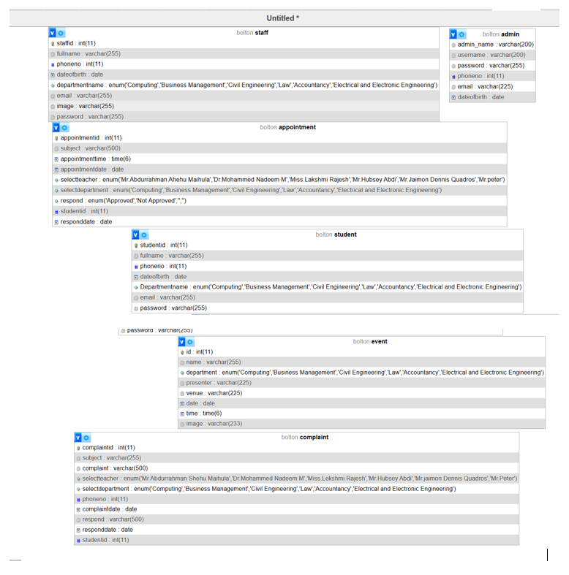

### 4b) Have a secured login and registration page

At the University of Bolton Help Desk, we have sperate login portals for students, staff, and admins. This setup ensures that each group gets personalized access and services. When staff members log in, they can access their dashboard and add events, contributing to the university’s activities. Meanwhile, admins handle registrations for both student and staff, ensuring smooth operations and support within the help desk system. It’s worth noting that our login pages are secured to protect user information.

**Login pages**

**Admin**

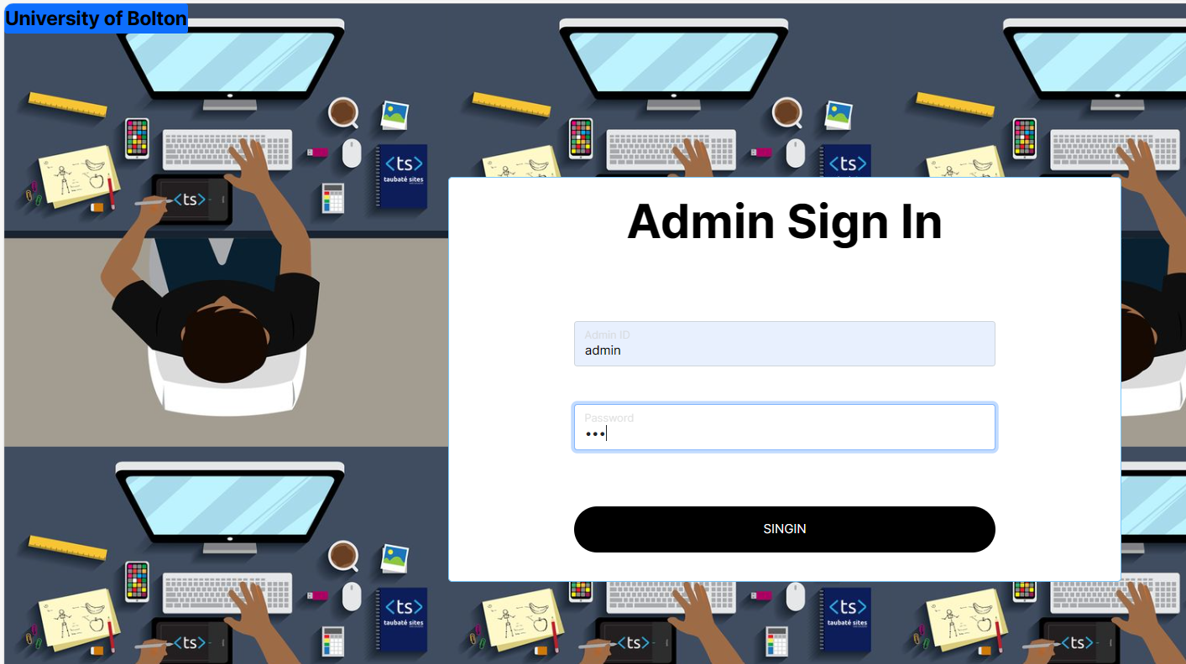

**Student**

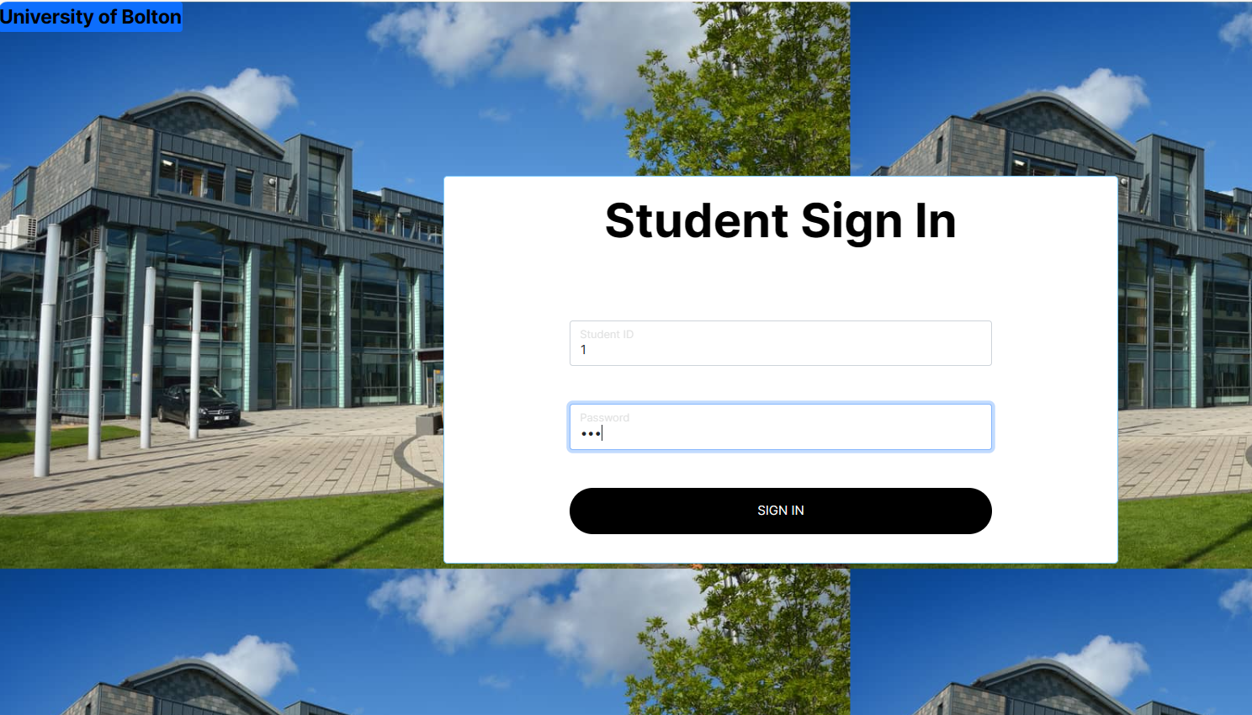

**Staff**

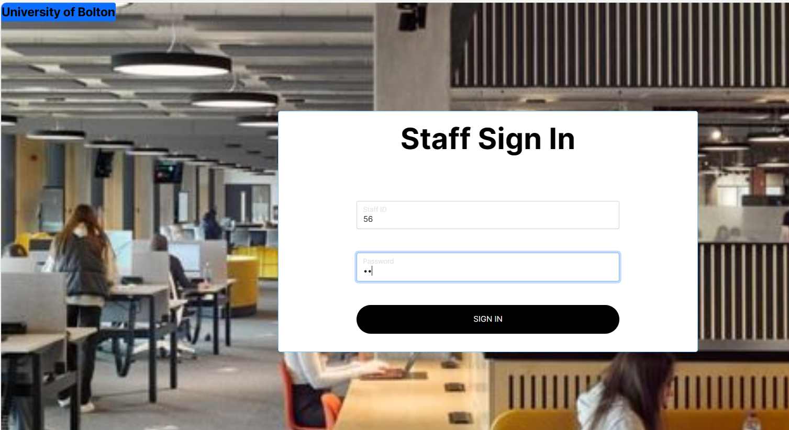

**Registration pages**

**Student**

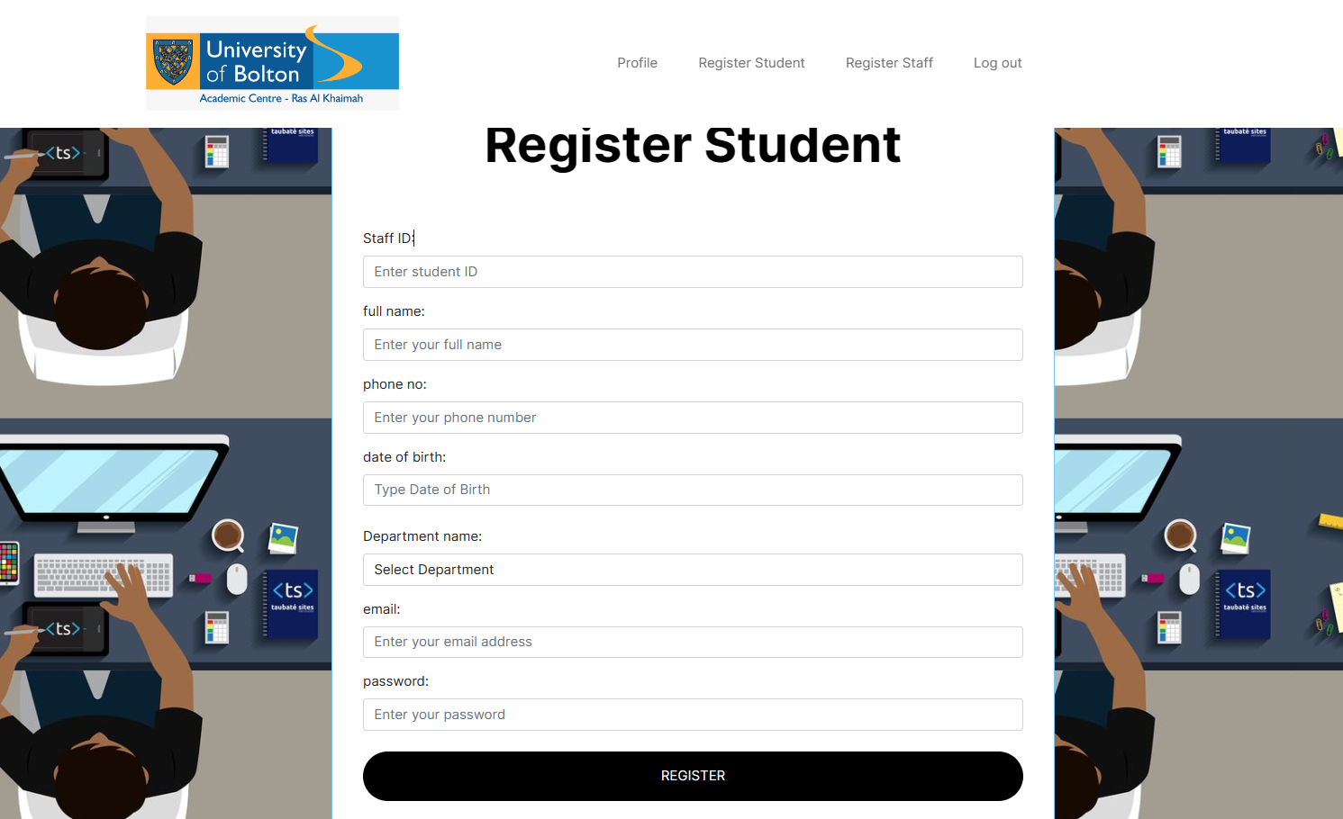

**Staff**

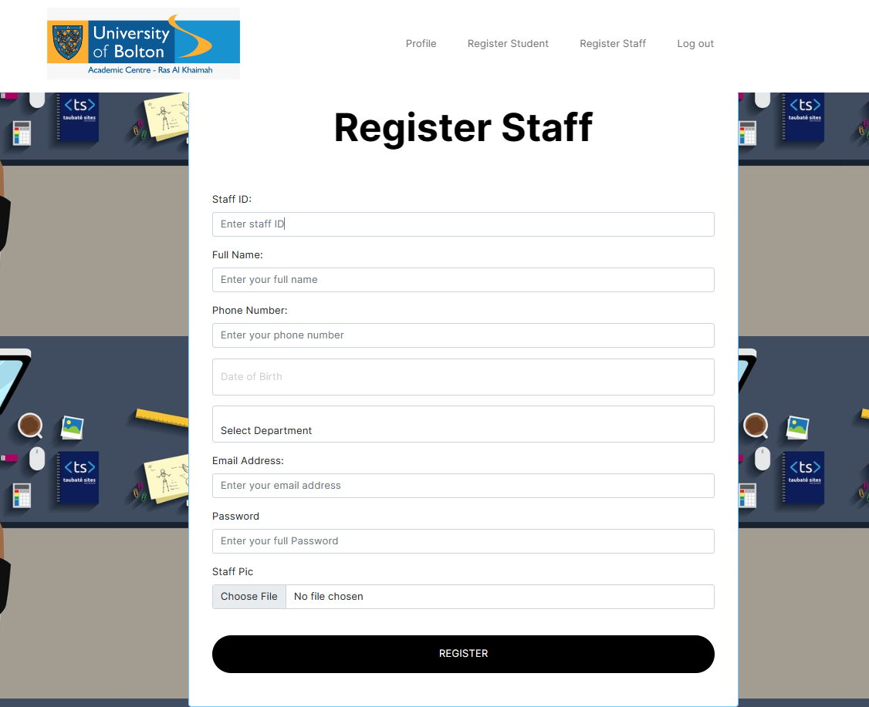

### 4c) Run on cross-platform (both mobile and web)

As we utilized a hybrid, cross-platform model, enabling our application to function seamlessly across web browsers and mobile devices. This compatibility is achieved through responsive design, ensuring optimal display on various screen sizes. By eliminating the need for separate codebases, development is streamlined, enhancing efficiency. The smooth transition from web to mobile enhances user experience, promoting engagement and accessibility. Overall, this approach fosters a cohesive and user-friendly experience across platforms.

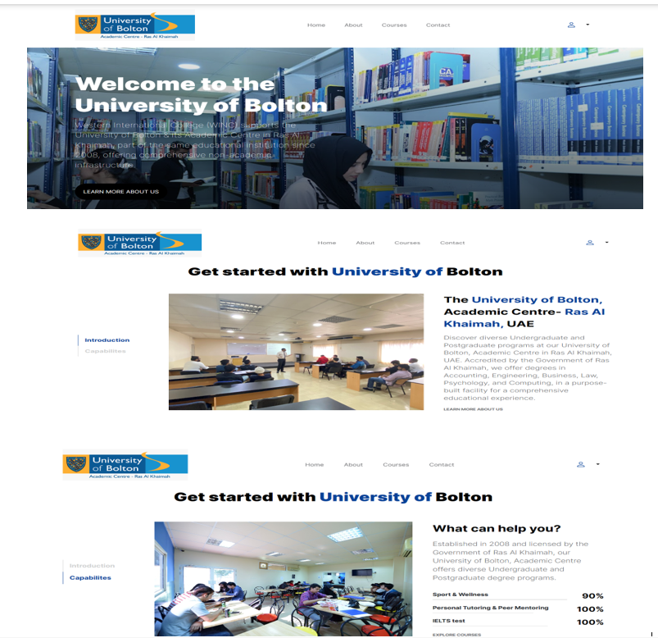

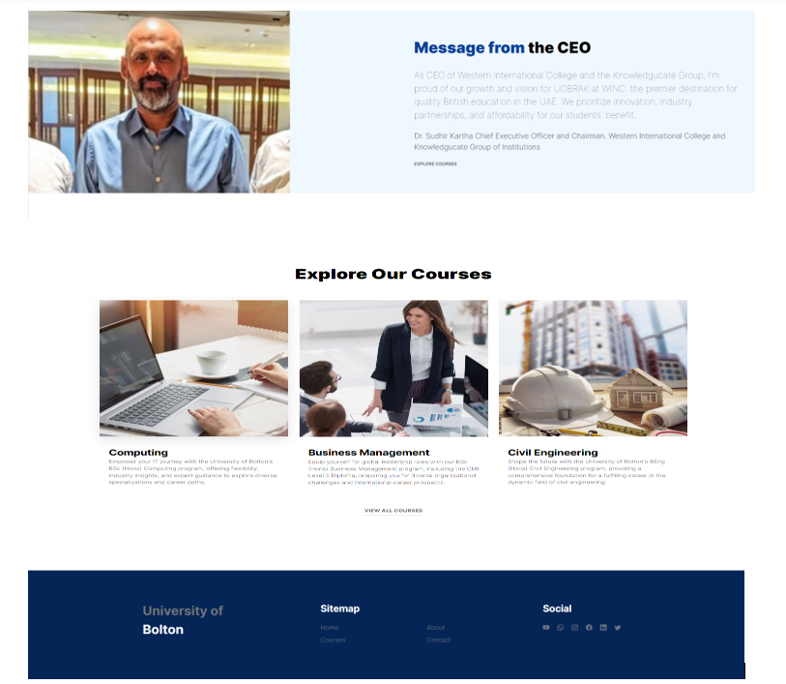

**Mobile**

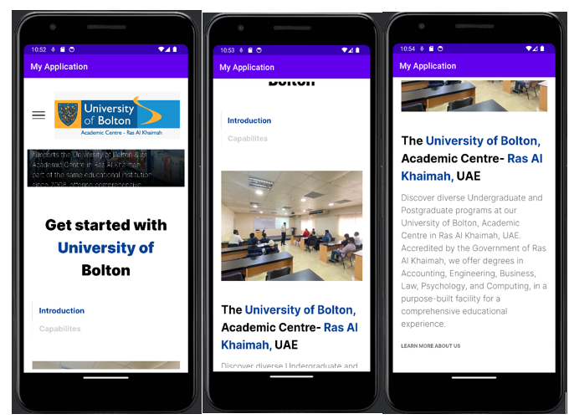

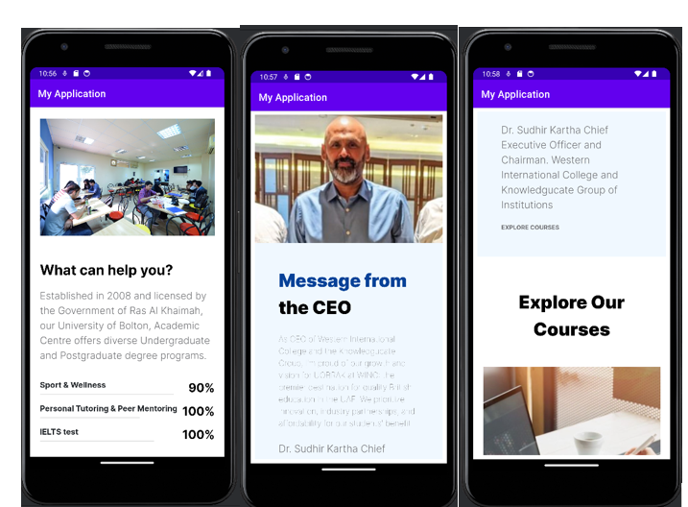

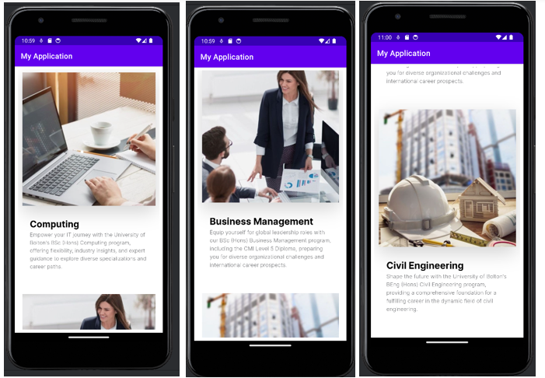

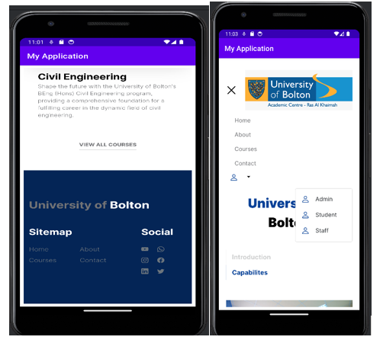

### 4d) Integrate e-marketing techniques.

Integrating e-marketing techniques adding social media accounts on platforms like You Tube, Facebook, Instagram, and Twitter helps us expand our reach and engage effectively with our audience. Each platform offers unique opportunities for content creation and interaction, showcasing our brand and building meaningful connections. Utilizing features like video content on YouTube, visual storytelling on Instagram, regular updates on Facebook, and real-time engagement on Twitter enhances our e-marking efforts and strengthens relationships with our followers.

**About Us**

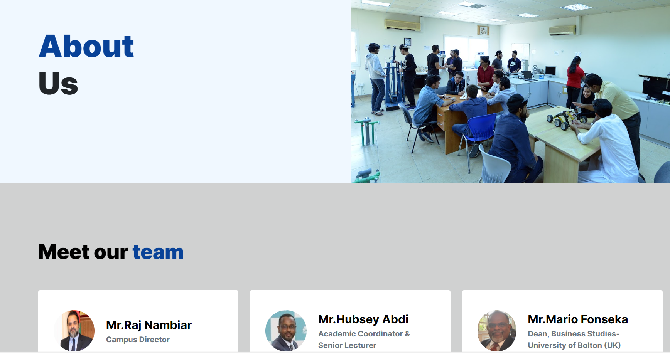

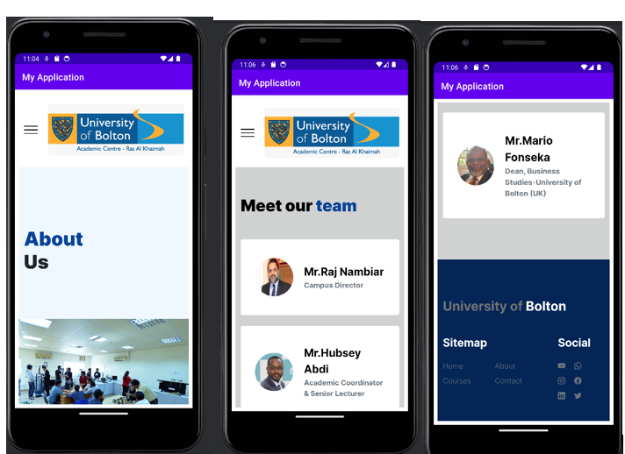

**YouTube**

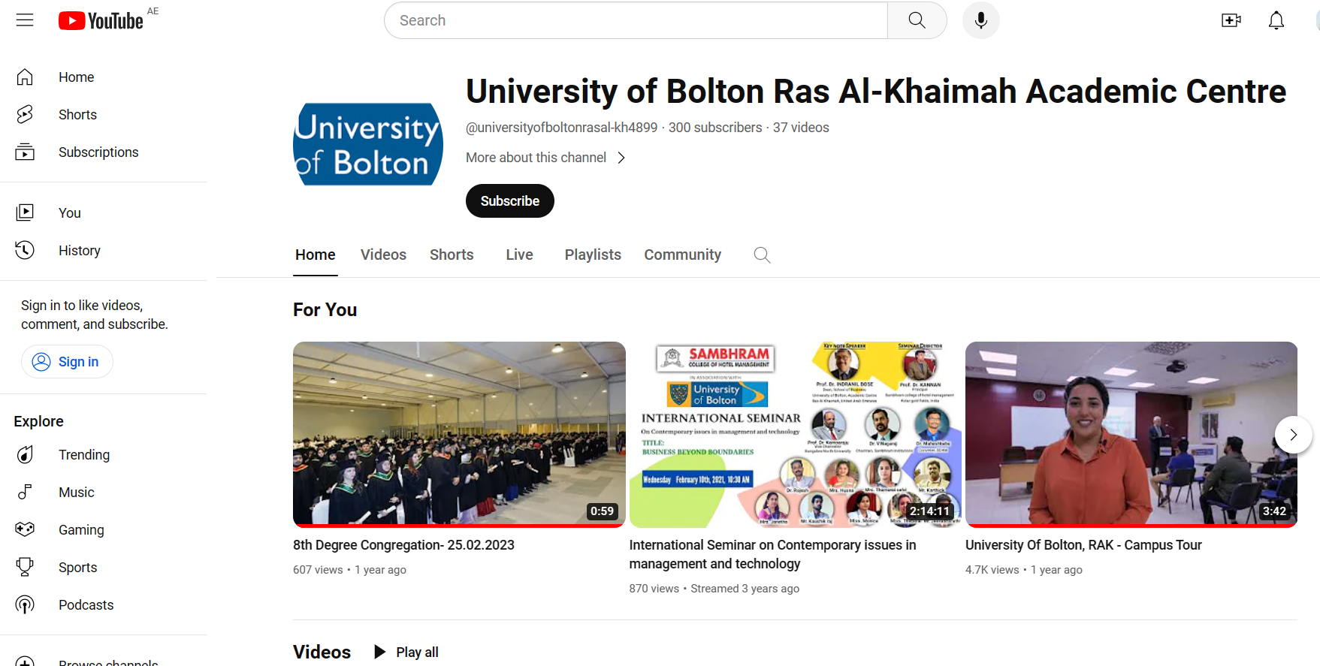

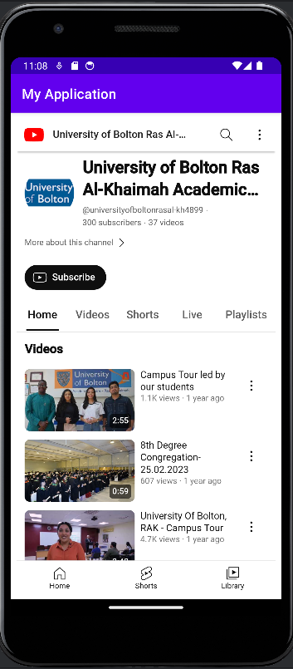

**Facebook**

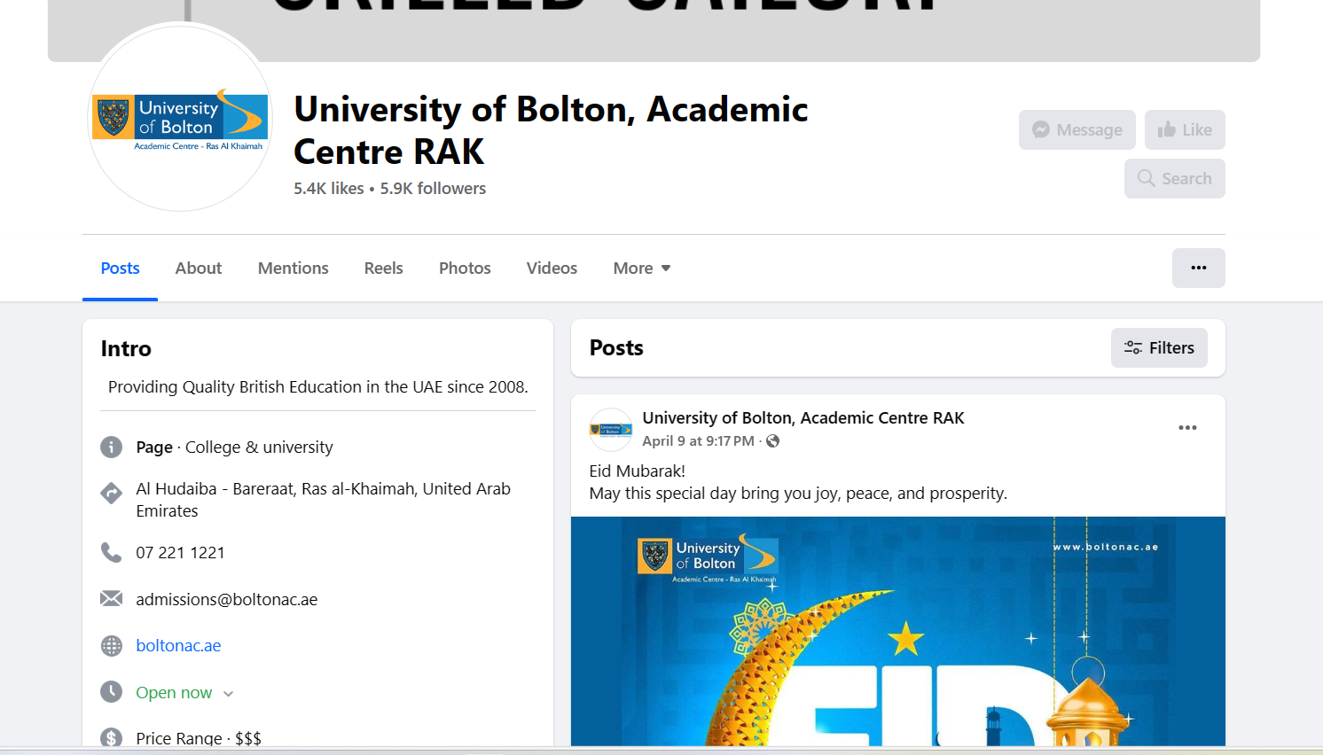

**Instagram**

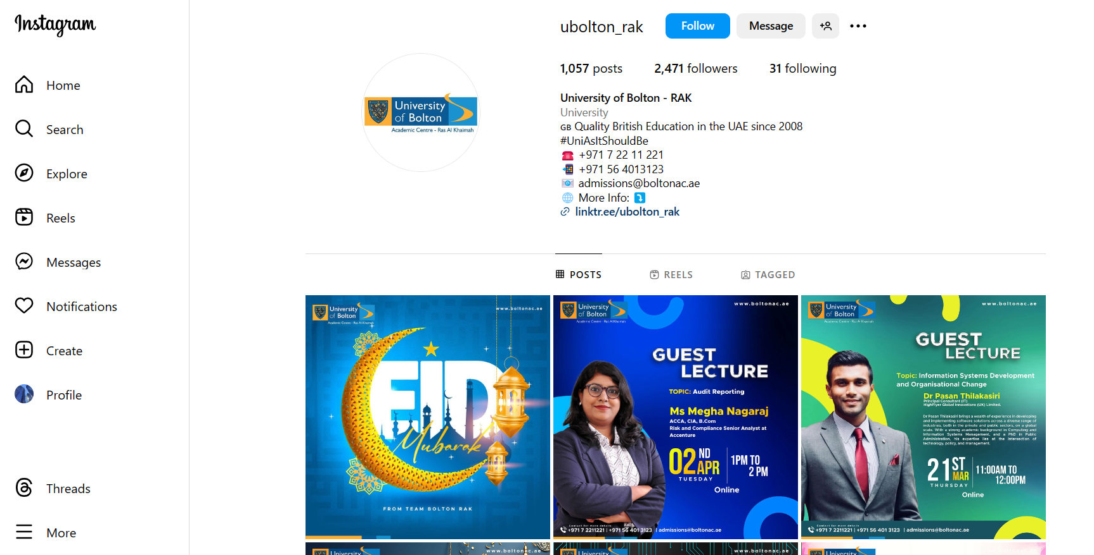

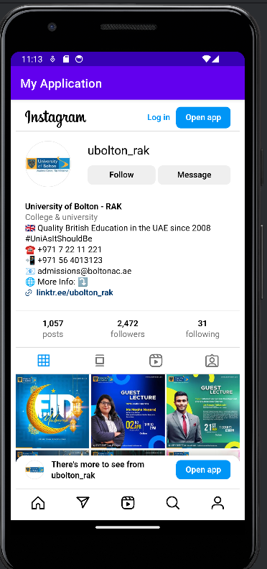

**Twitter**

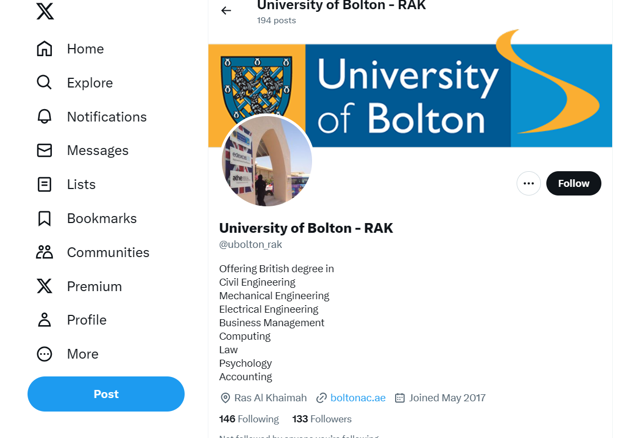

### 4d) Integrate multiple features that includes but not limited to:

### Complaint management

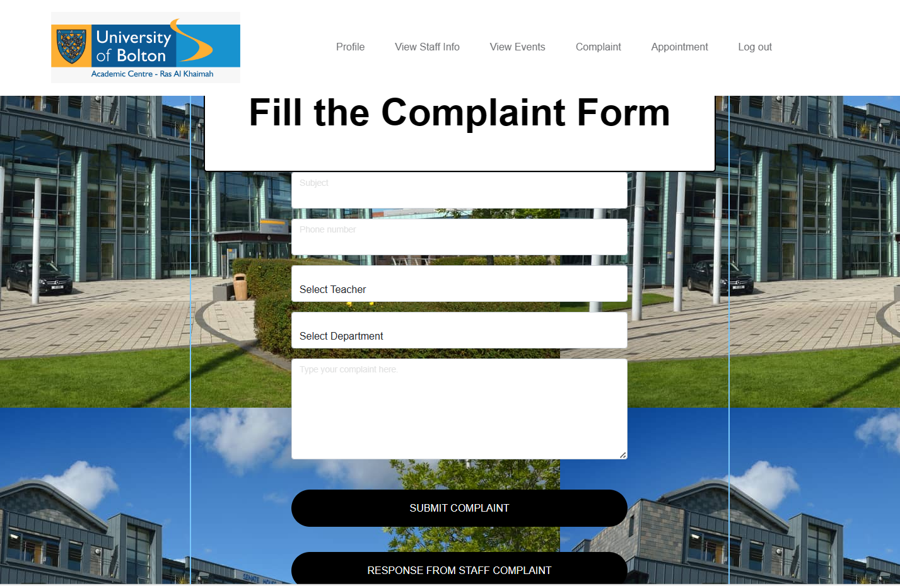

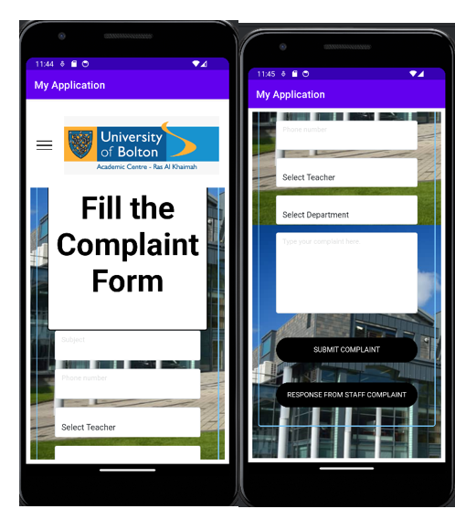

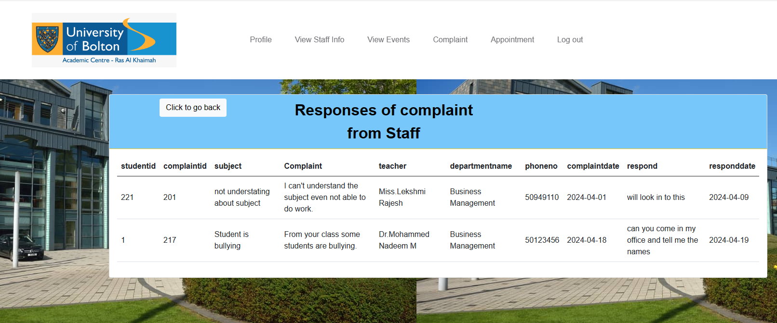

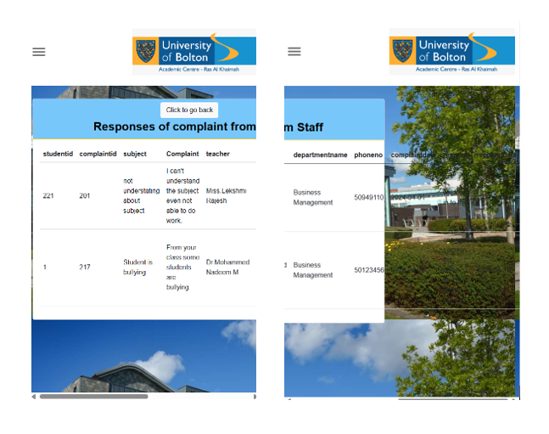

### Event management

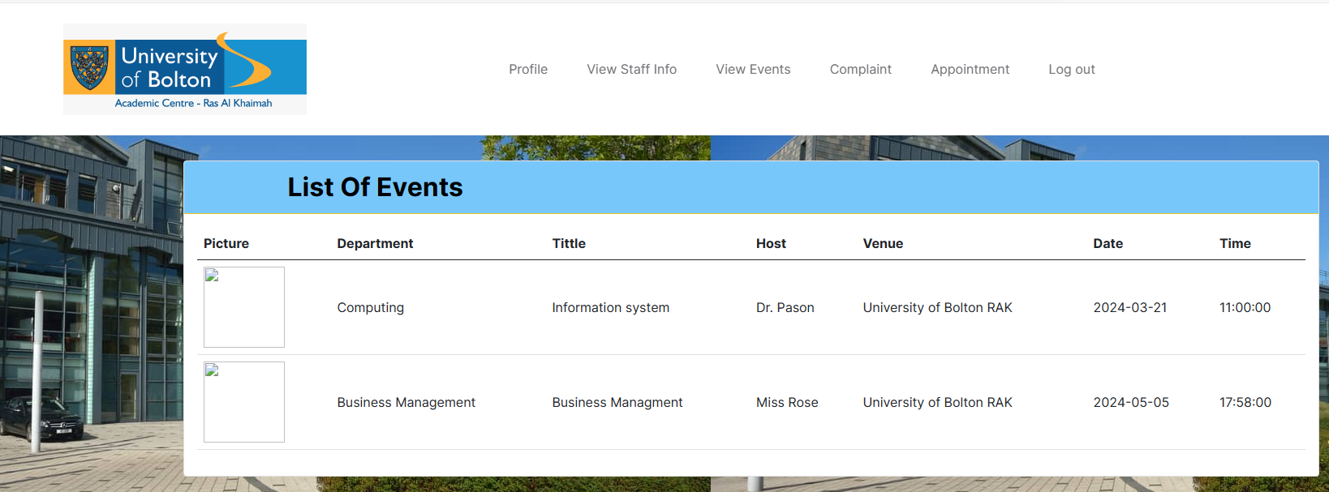

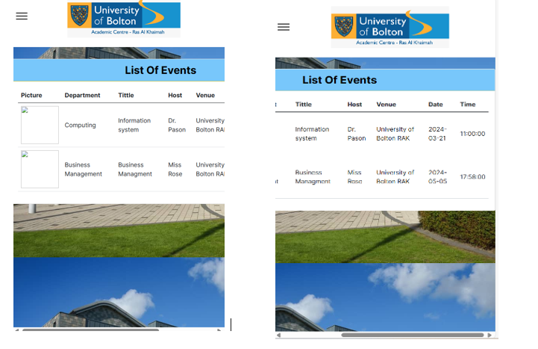

### Profile management

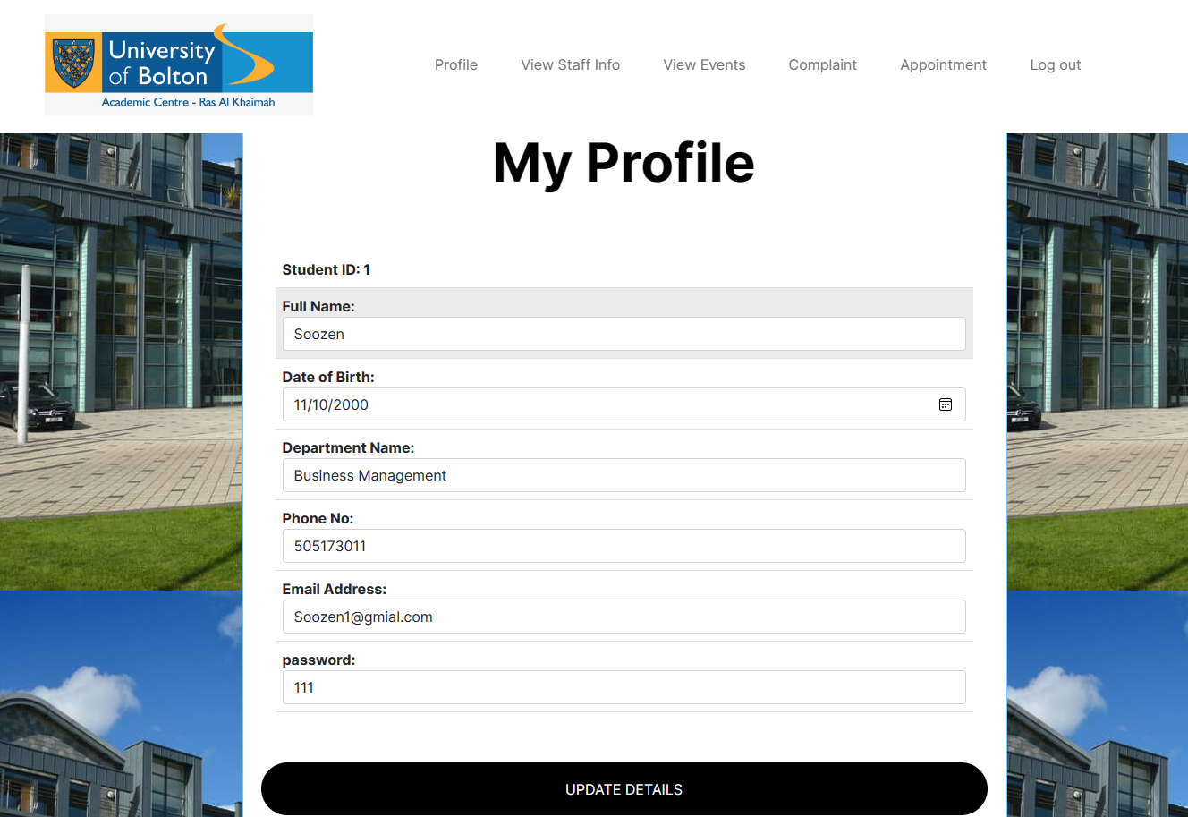

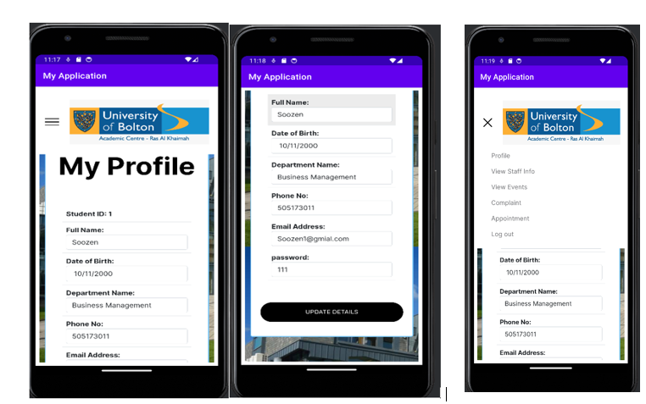

### Appointment management

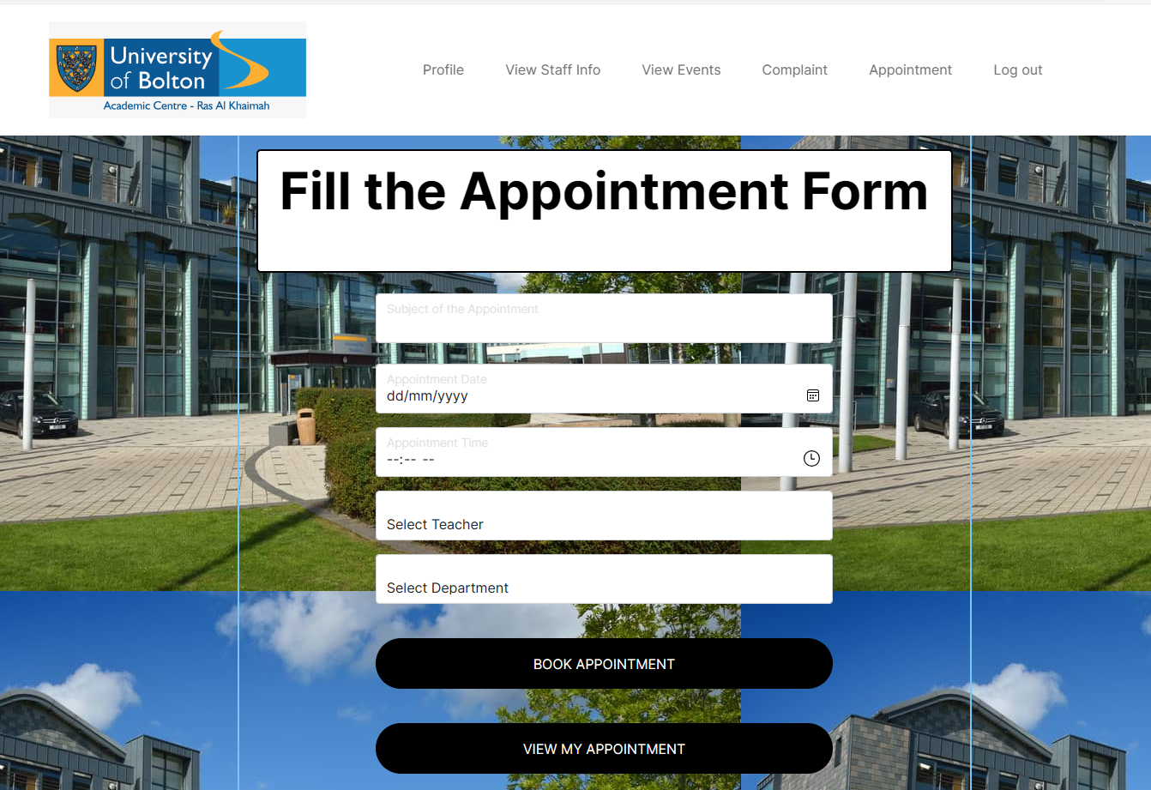

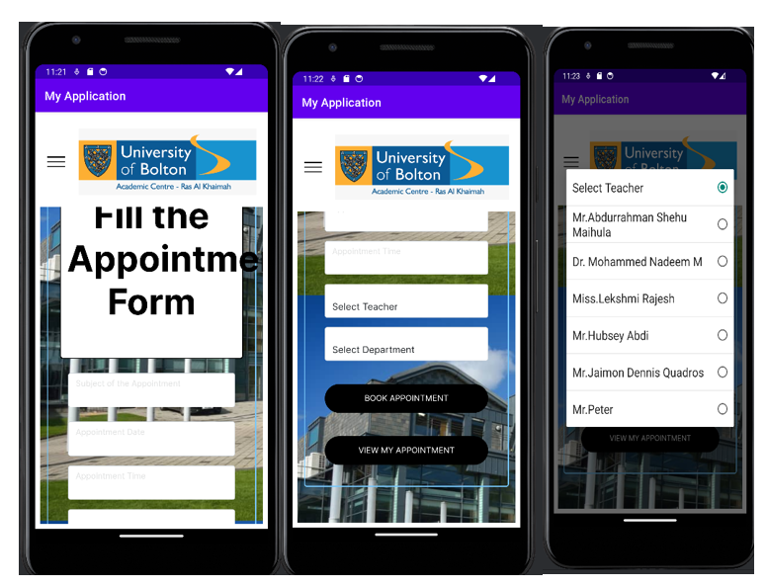

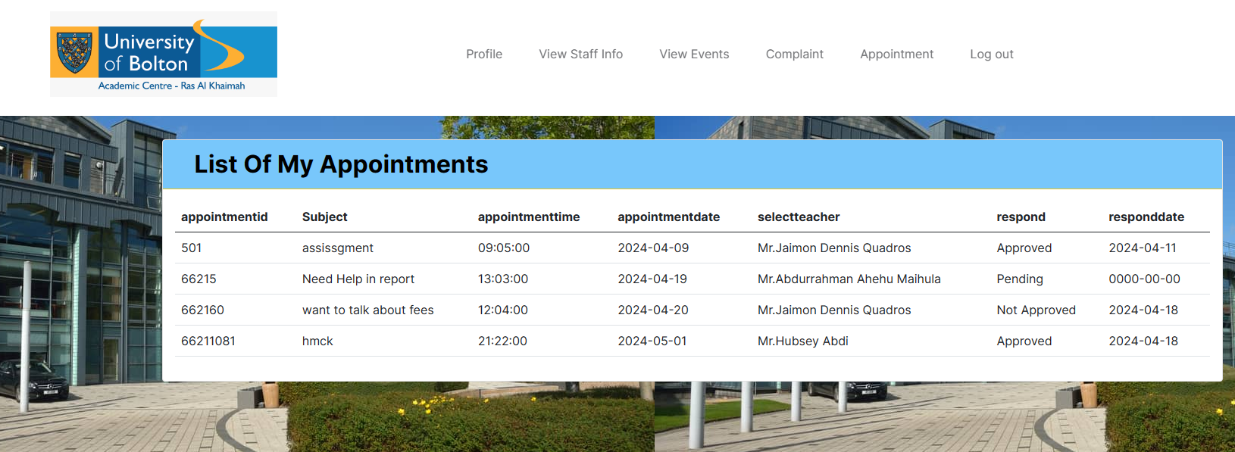

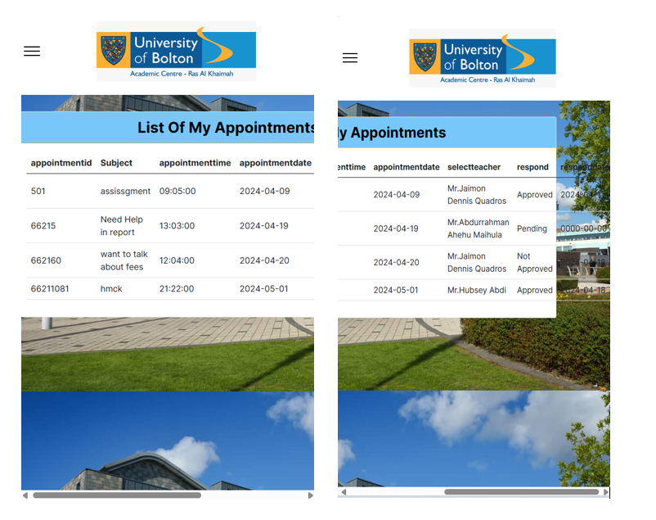

### 4e) Provide feature enhancement of the project.

While the initial feature requirement from the university were straightforward, we recognize that users can encounter errors during data entry. As developers, it’s crucial for us to ensure the integrity and quality of data within the database. To address this, we’ve implemented several enhancements to basic features, focusing on error prevention, data validation, and user-friendly interfaces. These enhancements not only improve the user experience but also contribute to maintaining accurate and reliable data throughout the system. **(Law Insider, 2024)**

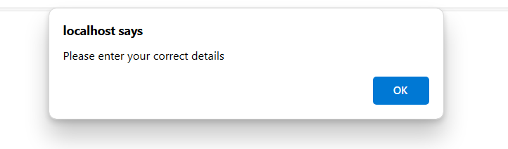If the user is entering incorrect information, then user may see an error message on website asking the user to input the correct details. This usually happens when login credentials or form data are not accurate or complete. To fix this, make sure the user double-checks their input for accuracy, fill in all required fields correctly, and verify their login information before submitting again.

The message “Please fill in the field” is a prompt indicating that a required field on a form has been left blank. It serves as a reminder to ensure that all necessary information is provided before proceeding. To address this, simply double-check the form for any missing details and make sure to fill in the required field(s) accordingly before submitting again.

When the user will register or making appointments or complaint remembering exact course names can be a bit of a hassle, and this can lead to mix-ups and inconsistencies in the system. But with dropdown menus, it’s like choosing from a department or teacher easy, straightforward, and no chance of getting the wrong department or teacher. It’s simple solution that keeps everything tidy and accurate in the database.

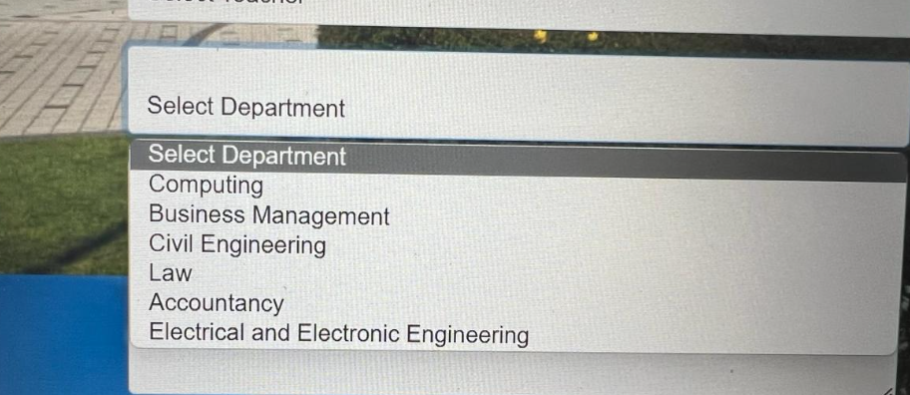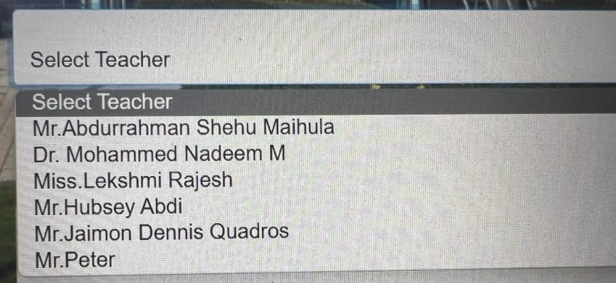

# **TASK 5**

## **Application Testing Methods**

### 5a) Examine testing methodologies

Testing methodologies are structured approaches used to plan and execute software testing activities effectively. They define how tests are designed, conducted, and evaluated, ensuring software quality and meeting user requirements. These methodologies encompass various testing types and criteria for success or failure. **(Indeed Career Guide, 2024)**

**Unit Testing:** Unit testing involves testing individual units or components of software, such as functions, classes, or methods, in isolation. The purpose is to verify that each unit performs as expected and meets its design specifications. This testing is typically done by developers and automated, ensuring that codes do not break existing functionality.

**Integration Testing:** Integrated focuses on testing how different units or modules of software work together when integrated. It checks for interactions, data flow, and interfaces between these units to ensure they collaborate seamlessly. Integration testing helps identify issues related to integration and dependencies between components. **(Indeed Career Guide, 2024)**

**System Testing:** System testing evaluates the entire software system as whole. It verifies that the system meets specified requirements, functions correctly in various environments, handles user input properly, and performs well under different conditions. System testing encompasses functional and non-functional testing to validate the system’s behavior and performance.

**Acceptance Testing:** Acceptance testing is conducted to determine if the software meets user requirements and is ready for deployment. It involves testing the software from the user’s perspective, focusing on real-world scenarios and user interactions. Stakeholders or end-users typically perform acceptance testing to ensure the software meets their expectations and delivers the desired functionality and user experience. **(Indeed Career Guide, 2024)**

### 5b) Produce a test plan and test cases as evidence for testing the application.

### **Test plan**

A test plan is like a roadmap for testing software, outlining what needs to be tested, how it will be tested, and the expected outcomes. It includes details on test cases, test scenarios, and the resources needed for testing. The goal is to ensure the software functions correctly, meets requirements, and delivers a positive user experience. **(Macarthur and Nelson, 1992)**

* **System Tests:** These test check how the application looks and works on different devices and web browsers. The goal is to make sure everything stays consistent and that all the features do what they’re supposed to . **(Macarthur and Nelson, 1992)**
* **Logic Tests:** These tests focus on how the application functions in real university environment. We’re checking if all the operations make sense and if the backend functions are producing the right results.

### **Test cases**

1.

|  |  |
| --- | --- |
| **Test Name** | **Admin Login page** |
| Test steps | 1. Click valid as admin, enter login information 2. Admin profile 3. Then click on register student |
| Test Input | Username: admin  Password: 222 |
| Expected Result | Register student pages will open |
| Pass / Fail | Pass |
| Screen short |  |

2.

|  |  |
| --- | --- |
| **Test Name** | **Student Login page** |
| Test steps | 1. Click Valid button student and enter Username and password 2. Then student portal will open |
| Test Input | Username: 1  Password:111 |
| Expected Result | Student portal page opened |
| Pass / Fail | Pass |
| Screen short |  |

|  |  |
| --- | --- |
| **Test Name** | **Update profile** |
| Test steps | 1.Click on update profile button  2. the details will be updated in the database |
| Test Input | Studentid: 1  Full Name: Soozen  Date of Birth: 11/10/2000  Department Name: Business Management  Phone No: 505173011  Email: Soozen1@gmail.com  Password:111 |
| Expected Result | Student profile updated |
| Pass / Fail | Pass |
| Screen short |  |

|  |  |
| --- | --- |
| **Test Name** | **Complaint page** |
| Test steps | * 1. Fill complaint form with appropriate information   2. Click on complaints |
| Test Input | Subject: Student is bullying  Phone no: 050123456  Teacher: Dr. Mohammed Nadeem M  Department: Business Management  Complaint : From your class some students are bullying. |
| Expected Result | Complaints table updates |
| Pass / Fail | Pass |
| Screen short |  |

|  |  |
| --- | --- |
| **Test Name** | **Appointment page** |
| Test steps | 1. Fill appointment form with appropriate information 2. Check appointment |
| Test Input | Subject: Need help in report  Teacher: Mr. Abdurrahman Shehu Maihula  Department: Computing  Date: 19/04/2024  Time: 1:03 pm |
| Expected Result | Appointment table updates |
| Pass / Fail | Pass |
| Screen short |  |

|  |  |
| --- | --- |
| **Test Name** | **Events page** |
| Test steps | 1. Click on view events button 2. Will view the even page |
| Test Input | N/A |
| Expected Result | Want to see the events or upcoming events |
| Pass / Fail | Pass |
| Screen short |  |

|  |  |
| --- | --- |
| **Test Name** | **Staff login page** |
| Test steps | 1. Click Valid button staff and enter Username and password 2. Then student portal will open |
| Test Input | Username: 1  Password: 123 |
| Expected Result | Staff portal page opened |
| Pass / Fail | Pass |
| Screen short |  |

|  |  |
| --- | --- |
| **Test Name** | **Update Staff profile page** |
| Test steps | 1.Click on update profile button  2. the details will be updated in the database |
| Test Input | Staffid: 1  Full Name: Mr. Abdi  Date of Birth: 23/10/1999  Department Name: Business Management  Phone No: 2147483647  Email: abdi1@gmail.com  Password:123 |
| Expected Result | Staff profile updated |
| Pass / Fail | Pass |
| Screen short |  |

# **REFERNCING**

## **Website**

* Indeed Career Guide. (2024) *Software Testing Methodologies: A Complete Guide*. [Online] Available at: https://www.indeed.com/career-advice/career-development/testing-methodologies [Accessed 17 Apr. 2024].
* Law Insider. (2024) *Software Feature Enhancement Definition | Law Insider*. [Online] Available at: https://www.lawinsider.com/dictionary/software-feature-enhancement [Accessed 17 Apr. 2024].

‌

## **Book**

* Cortellessa, V., Antinisca Di Marco and Inverardi, P. (2011). *Model-Based Software Performance Analysis*. Springer Science & Business Media.
* Koch, A.S. (2004). Agile Software Development. Artech House Publishers.

## **Journal**

* Macarthur, E. and Nelson, W. (1992). Accelerated Testing: Statistical Models, Test Plans, and Data Analyses. Applied Statistics, 41(1), p.224. doi:https://doi.org/10.2307/2347642.

## **Images**

* Fig1: Ttgtmedia.com. (2024) Available at: https://cdn.ttgtmedia.com/rms/onlineimages/whatis-waterfall_model_mobile.png [Accessed 17 Apr. 2024].
* Fig2: Sunbytes.io. (2024) Available at: https://sunbytes.io/app/uploads/2023/03/Colorful-Process-Pie-Chart.png [Accessed 17 Apr. 2024].
* Fg3: Wikimedia.org. (2024) Available at: https://upload.wikimedia.org/wikipedia/commons/thumb/e/ec/Spiral_model_%28Boehm%2C_1988%29.svg/900px-Spiral_model_%28Boehm%2C_1988%29.svg.png?20100116192230 [Accessed 17 Apr. 2024].
* Fg4: Tutorialspoint.com. (2024) Available at: https://www.tutorialspoint.com/sdlc/images/sdlc_v_model.jpg [Accessed 17 Apr. 2024].
* Fg5: Pinimg.com. (2024) Available at: https://i.pinimg.com/736x/78/44/c5/7844c59b4ac7c65f9cff009f06dc5fba.jpg [Accessed 17 Apr. 2024].

‌

‌

‌

‌